Paper-protype testing

In order to develop a user experience/user interface that enables efficiency for the teacher, we planned to make a paper prototype. This way we could see how our projected interface would perform without having to make the actual product. Another benefit was that our test subject could rearrange the application as he saw fit. This opened up the discussion for how the user flow would be and how he imagined it. Crucial features arose as we played which the team hadn’t thought about before.

# Homepage

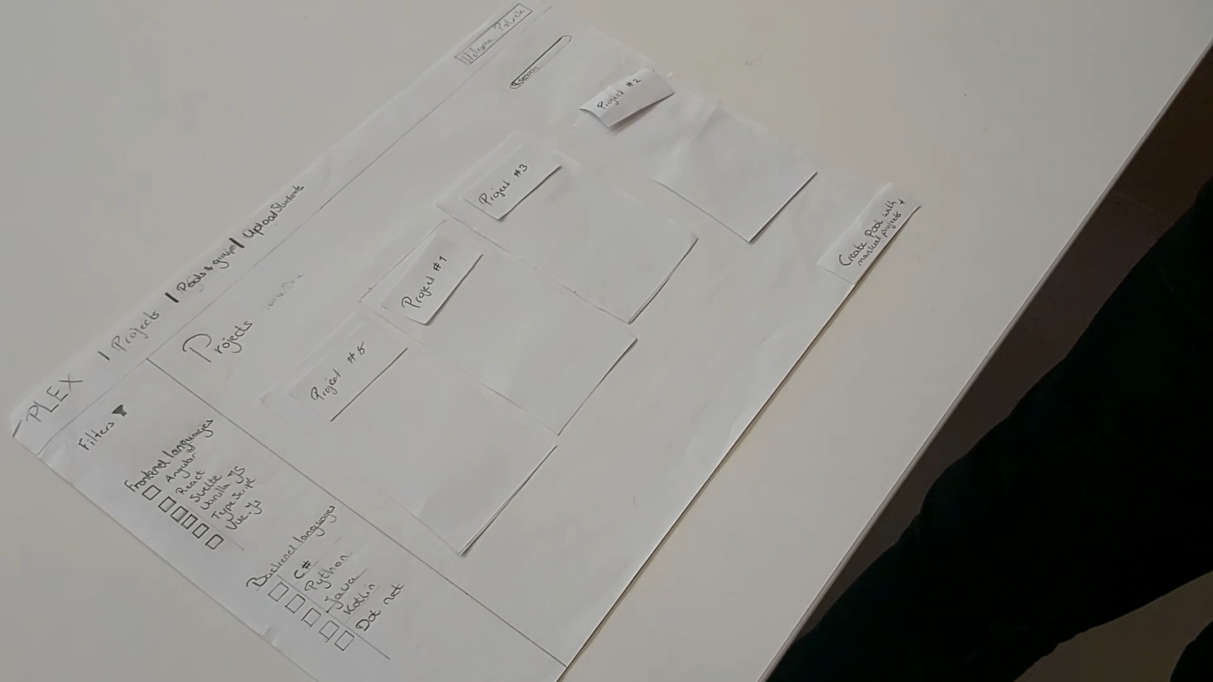We started off with how we envisioned the layout to be at the landing page, the “Home Page”. All of the projects on the homepage are fetched from the Dex database. On top, there is a universal navbar with links leading to: ***the projects(serving as the homepage), [Playlists] and groups***. On the left side of the page we see a collection of filters which you can apply to the projects. They were focussed on the technologies present in the projects. In the top right corner, you can see the user being logged in or a button prompting you to log in.

The function of this page is to ***mark projects and to then add those marked projects to playlists.*** Whenever you would click on the project, the project itself would expand as an overlaying view (hadn’t simulated that) that displays the ***title, description, tags and the project owner.***

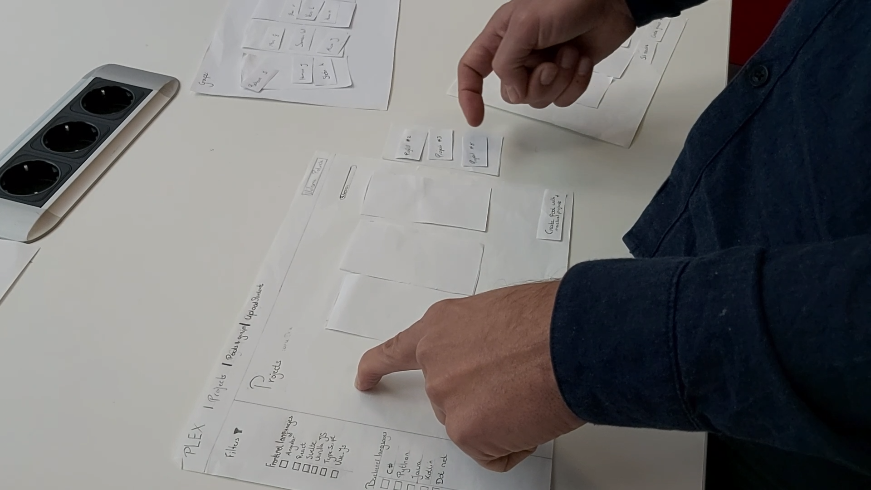

Quickly after we started, our prototyper had some input about the view whenever a project had been added. The idea was to highlight the projects but as he mentioned, in case there are a lot of projects, you won’t be able to have a quick overview of what you had already marked. So, as you can see in the picture above, we played around with the idea of ***a smaller window on the side that would list all of the marked projects***.

He also notified me of the idea of having a so-called “Modal” view of the projects. This way you still have all the projects present in the background and you won’t have to navigate back to the projects. He asked the question of what the cards in the overview would present. We had the idea to show the title, tags, bit of the description and project owner.

Something he would have loved to see is ***the ability to add projects himself due to the partners in education programme.*** They are not going to upload their own projects to the DEX platform due to the way this programme functions. So our prototyper proposed that we’d either:

1. Create a function that allows him to make a project/save it on Plex
2. Redirect the user to the DEX project creation page or incorporate it into our application

# Playlists

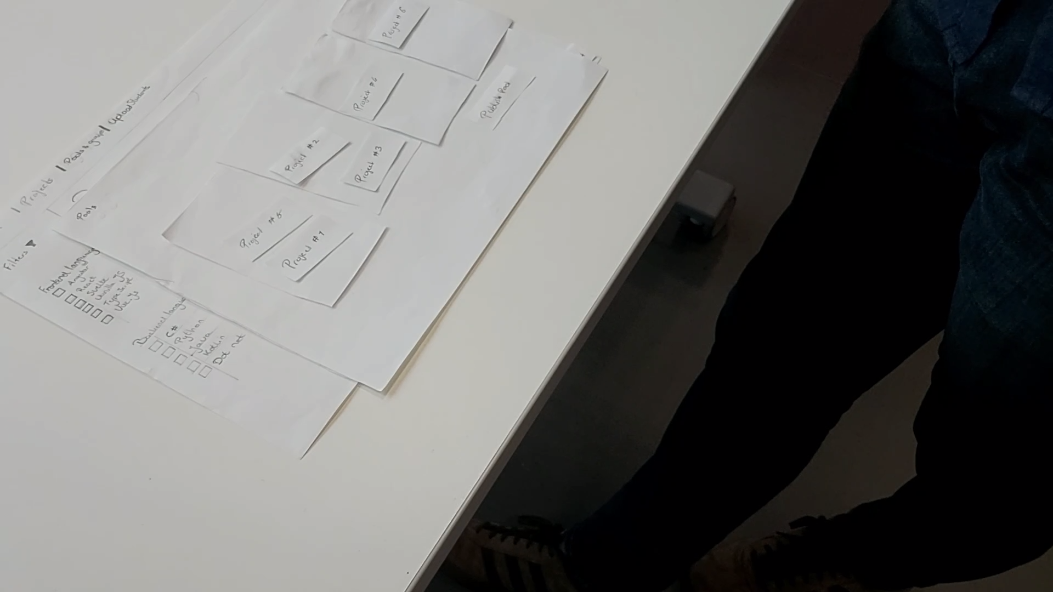

In the overview of the Playlists you can see the projects and are able to publish them. Because your playlists serve as ***templates***, you can use them for other semesters and adjust them to your liking by removing a project or changing the description. The title of the playlist will be shown on the top of the cards. When having clicked on the singular playlist, you can then proceed to a page where all of the projects will be shown as well as the ability to ***publish*** it.

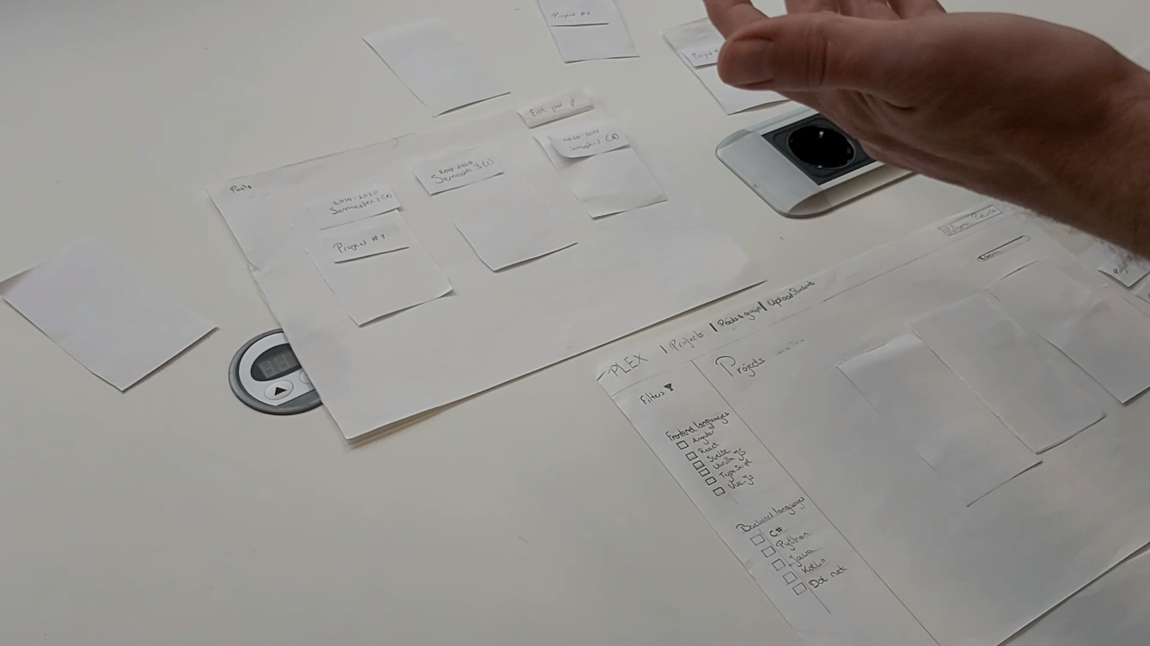

Due to the way we named the component, our idea hadn’t come across properly. Here we see a more proper execution by the prototyper as to how he saw it. He already mentioned that the edit button should be somewhere in the ***top right*** of the page. Another thing he mentioned was that the ***clone button*** should be somewhere in the ***bottom right*** part of the page. This button would serve as a way to utilize the templates by cloning them.

One of the major concerns was that there needed to be an overview which you could glance over and see all of the playlists (as much as possible). We can conclude that just the “Cards” system isn’t going to suffice and we need to create a hybrid of a “list” view and cards in order to make it work more efficiently.

# Playlist

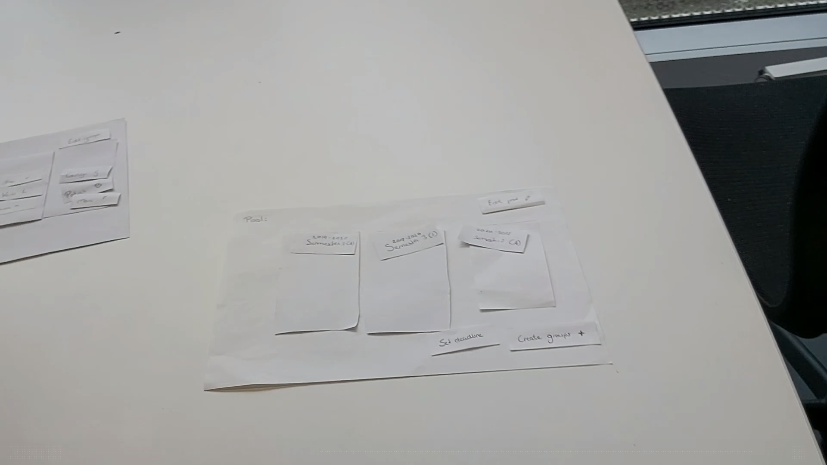

This is the dedicated page of the playlist. All of the projects you had previously added will show up here. The title of the pool will be shown in the ***top left corner*** of the page and the ability to edit the pool (change the title, add/remove projects etc) will be presented by showing a button in the ***top right corner*** of the page.

The main changes our prototyper suggested was to clarify the function of what you can do on the ***Playlists*** and ***Playlist*** page. It was too unclear at this moment.

So we brainstormed together and came to the conclusion that the Playlist page will mainly focus on:

1. Showcasing the projects belonging to the playlist
2. The ability to create groups by publishing the playlist
3. Edit the pool in terms of projects
4. Upload the students for which the playlist is for

And on the other hand the Playlists page will focus on:

1. Showcasing the Playlists as a whole
2. The ability to clone a playlist

There still is a slight overlap but we will make an actual prototype based on code in order to work out a MVP.

# Groups/Group

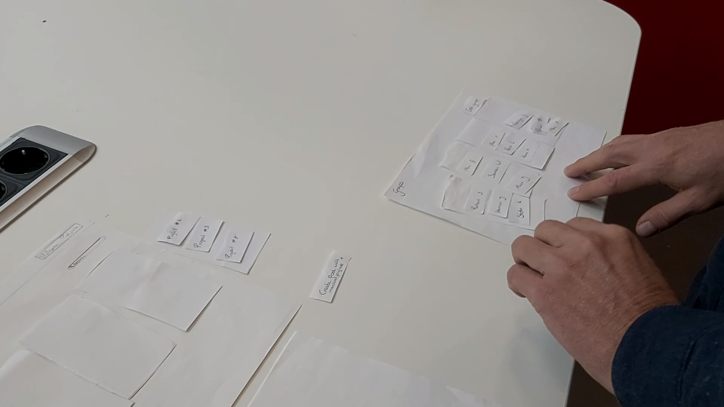

One of the components that needed further clarification was the component of ***Groups and the group.*** We thought of it as an overview that was part of the playlist whenever you published the playlist. As soon as the deadline has been met, which you previously set during the publishing of a playlist, the application will automatically make groups based on the preferences of students.

Even though the prototyper didn’t tinker much with the page, he had a lot to say about it. Make it a dedicated page. This way you can quickly head on over to it and have an overview of what the groups are. The structure should be something along the lines of this:

[Name of the playlist and which semester it is for] (Perhaps call this Groups Dashboard) →

The collection of groups and their respective projects as the title (Groups) →

The students of the group (Group)

This way you maintain clarity for the user, each page has their dedicated function and should thus enable the proper workflow.

On the groups page, there should be a button in the top right corner to edit the groups. The teacher could for example edit a group in terms of the division of students or what the name should be. That would enable a new view of the groups showing as cards and the students are drag and droppable. When you’re done, you can click a button in the bottom right corner to confirm the adjustments you’ve made.

When the second deadline has been met, for when the teacher has to publish the groups and their division has been completed, the teacher will be notified to look at one last time and submit the changes. Which will then notify the students of their groups.